Standard Versi on of WPS Off i ce Sui te wi th PDF Edi tor - https:// [www. wps. com](http://www.wps.com/)

# Brainstorm

**TIP**

You can select a sticky note and hit the pencil [switch to sketch] icon to start drawing!

## Before you collaborate

#### A little bit of preparation goes a long way with this session. Here’s what you need to do to get going.

**10 minutes**

**1**

**Define your problem statement**

What problem are you trying to solve? Frame your problem as a How Might We statement. This will be the focus of your brainstorm.

**5 minutes**

**2**

**Brainstorm**

Write down any ideas that come to mind that address your problem statement.

**10 minutes**

**3**

## Group ideas

#### Take turns sharing your ideas while clustering similar or related notes as you go. Once all sticky notes have been grouped, give each cluster a sentence-like label. If a cluster is bigger than six sticky notes, try and see if you and break it up into smaller sub-groups.

**20 minutes**

**4**

**Prioritize**

Your team should all be on the same page about what's important moving forward. Place your ideas on this grid to determine which ideas are important and which are feasible.

**20 minutes**

**After you collaborate**

You can export the mural as an image or pdf to share with members of your company who might find it helpful.

**Quick add-ons**

**& idea prioritization**

##### A Team gathering

AHAMED JOHN

SYETHOON IRFANA

THIRISHA

VINOTHINI

**TIP**

Add customizable tags to sticky notes to make it easier to find, browse, organize, and categorize important ideas as themes within your mural.

Define who should participate in the session and send an

The data collected Before

**PROBLEM**

**How might we [your problem statement]?**

All the duplicate

For assening the

Mean absolute

RMSE is the tool

It is defined as the Error is defined as Less the RMSE ,

It is more popular It gives an idea

Statiscallty, it is

##### A Share the mural

can be use as raw proceeding to

and null values

exhibition of these

percentage error

that helps

square root of the the difference

the better the

in calculating

about how much

mean or average of

invite. Share relevant information or pre-work ahead.

certain parameters

are remove from

algorithms definite

(MAPE) Root

in determing how

average of the

between

performance the

errors in forecasting. accurately the model the absolute

**Share a view link** to the mural with stakeholders to keep

which would be no the actual data data set and

boundaries are

mean square

accurately

squares of all the the actual and

model is.

is evaluating the

percentage errors

use and also certain the data needs specific data can

thought of

(RMSE)

the model the

errors.

predicted

predictions.

of forecasts.

Use this template in your own

data can't be use to be filtered

the way it would be

should clean

present in data set

be converted to a usable format

making in prediction

value.

them in the loop about the outcomes of the session.

Various

These loads of the

It calculates how

It measures the

Usually, an RMSE Mean absolute

Error is

Less the MAPE,

conventional

machin learning

muchthe error the standard of

score of less than 1 percentage error is

characterised by the better the exhibition

**B Set the goal**

machine learning techniques are

model creates

predictions

is considered the most often used

contrast between the of the model.

### brainstorming sessions so your team

can unleash their imagination and start shaping concepts even if you're not sitting in the same room.

Think about the problem you'll be focusing on solving in the brainstorming session.

**C Learn how to use the facilitation tools**

Use the Facilitation Superpowers to run a happy and

algorithms are used for create a model for flight fare prediction which is ANN,LR

executed uing the sci-kit-learn library in python.

while making these predictions

best.

in regression

problems.

actual and predicted value.

**B Export the mural**

Export a copy of the mural as a PNG or PDF to attach to emails, include in slides, or save in your drive.

**10 minutes** to prepare

**1 hour** to collaborate

**2-8 people** recommended

productive session.

[**Open article**](https://support.mural.co/en/articles/2113740-facilitation-superpowers)

**Key rules of brainstorming**

To run an smooth and productive session

**Person 5**

|  |  |  |
| --- | --- | --- |
|  |  |  |
|  |  |
|  |  |  |

**Person 6**

|  |  |  |
| --- | --- | --- |
|  |  |  |
|  |  |
|  |  |  |

**Person 7**

|  |  |  |
| --- | --- | --- |
|  |  |  |
|  |  |
|  |  |  |

**Person 8**

|  |  |  |
| --- | --- | --- |
|  |  |  |
|  |  |
|  |  |  |

**Keep moving forward**

**Strategy blueprint**

Define the components of a new idea or strategy.

[**Open the template**](https://app.mural.co/template/e95f612a-f72a-4772-bc48-545aaa04e0c9/984865a6-0a96-4472-a48d-47639307b3ca)

**Customer experience journey map**

Stay in topic.

Defer judgment.

Encourage wild ideas.

Listen to others.

**Importance**

If each of these

Understand customer needs, motivations, and obstacles for an experience.

[**Open the template**](https://app.mural.co/template/b7114010-3a67-4d63-a51d-6f2cedc9633f/c1b465ab-57af-4624-8faf-ebb312edc0eb)

Go for volume. If possible, be visual.

tasks could get done without any difficulty or cost, which would have the most positive impact?

**Strengths, weaknesses, opportunities & threats**

Identify strengths, weaknesses, opportunities, and threats (SWOT) to develop a plan.

|  |  |
| --- | --- |
|  |  |
|  |  |

[**Open the template**](https://app.mural.co/template/6a062671-89ee-4b76-9409-2603d8b098be/ca270343-1d54-4952-9d8c-fbc303ffd0f2)

**TIP**

Participants can use their cursors to point at where sticky notes should go on the grid. The facilitator can confirm the spot by using the laser pointer holding the **H key** on the keyboard.

[**Share template feedback**](https://muralco.typeform.com/to/CiqaHVat?typeform-source=app.mural.co)

[**Share template feedback**](https://muralco.typeform.com/to/CiqaHVat?typeform-source=app.mural.co)

**Feasibility**

Regardless of their importance, which tasks are more feasible than others? (Cost, time, effort, complexity, etc.)

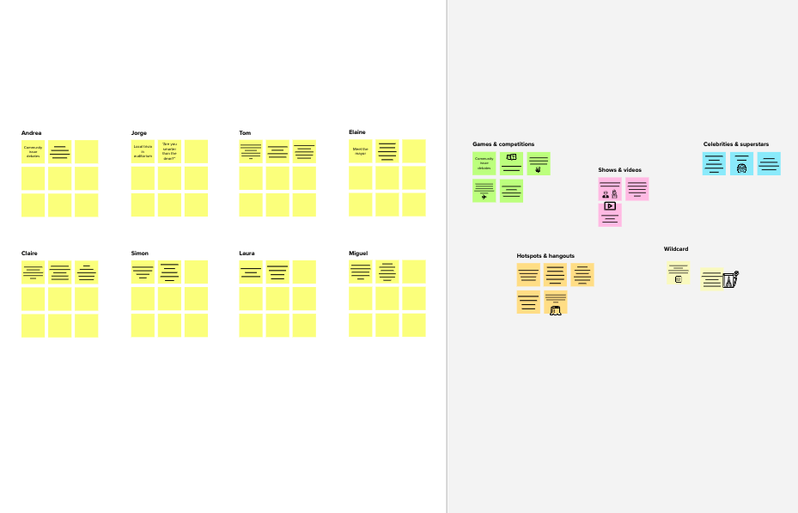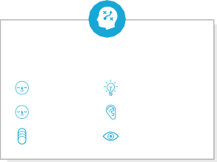

**Template**

**Need some inspiration?**

See a finished version of this template to kickstart your work.

[**Open example**](https://app.mural.co/template/e5a93b7b-49f2-48c9-afd7-a635d860eba6/93f1b98d-b2d2-4695-8e85-7e9c0d2fd9b9)